**Money Management Android App For Ease In Trading**

Vivek Rugale, Jayant Kulkarni

Department of Instrumentation and Control Engineering

Vishwakarma Institute of Technology, Pune

*Abstract*— A proper management of money is always a very important factor when it comes to investments especially in the stock market. The proposed android application in this paper helps in money management for investments in the stocks. The app consists of user-friendly pages and sections for good experience. The app also helps in deciding the quantity of particular stocks depending on the risk user willing to take.

Keywords— Android studio, investments, money management, stocks.

# **Introduction**

# For a good trade in stock markets, one should be able to manage his money efficiently so that the outcome will be a good profit. Most of the time small profits and large losses can be seen due to bad money management while trading. People often face huge losses in trading unplanned investments and random quantities of the stocks to be bought. So managing money becomes very important to avoid miscalculations at the end of a trade. A proper amount of money with a proper quantity of stocks will result in affordable losses in the worst case scenario. The Objective of this project is to make a mobile application where traders will be able to study the money they are investing in the various stocks. The app will work on the amount of risk the user is willing to take and will suggest the numbers accordingly. The app will also be able to compute the quantity of a particular stock to be bought.

**II.** **Methodology**

The app is built using android studio software. There is no need of internet for the working of the app. The app is made to totally work offline. The data is being stored in the device only using shared preferences in android programming. Programming language used is java. Device storage also provides faster refresh rate. Design section describes the different pages in the application and their use.

**III. Design**

The app consists of mainly five pages each named as portfolio stats, possible trades, open trades and closed trades. Following block diagram shows the basic architecture of the application.

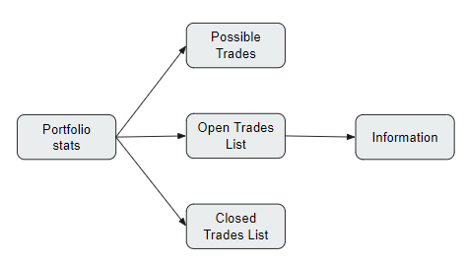

The blocks above represent the five pages the application has. Each of which has certain functionality.

1. **Portfolio Stats**

This page works as the main interface of the application as a home page. It features all the data related to the investment.

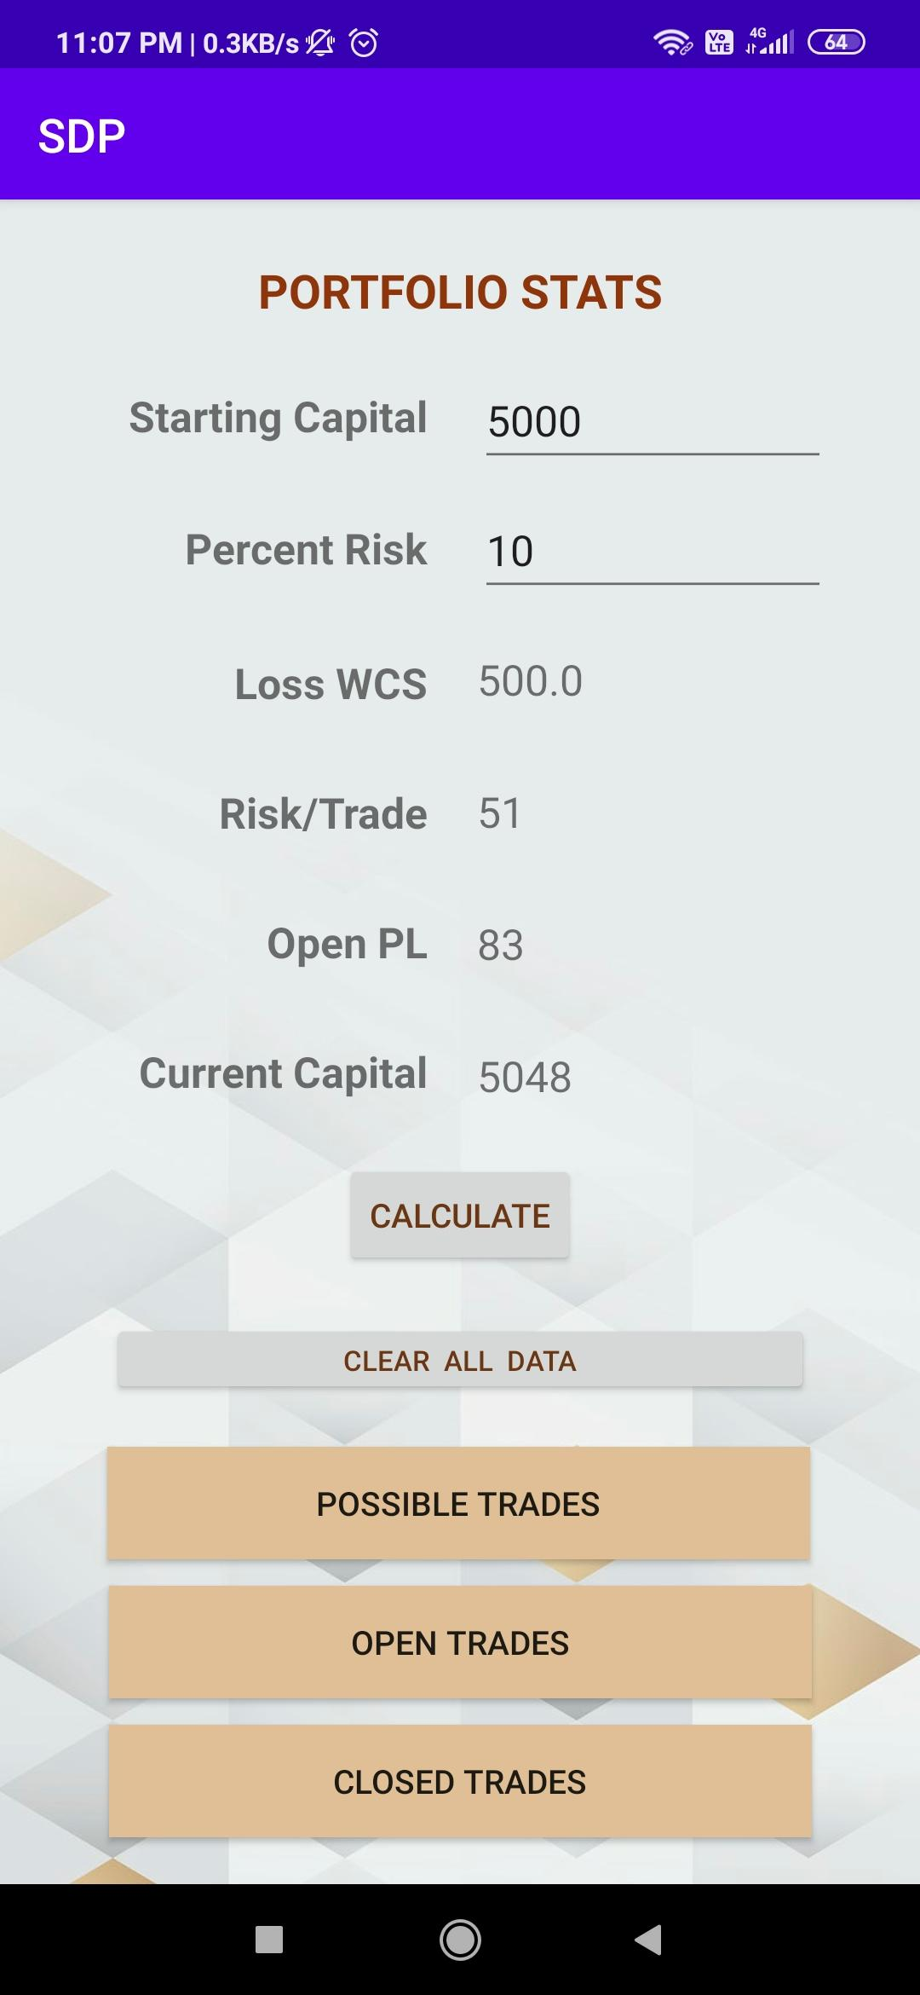

User will have to input the starting capital and percent risk on that capital he\she is willing to take. The app will calculate the loss in the worst-case scenario and risk to be taken per trade. The page also shows the open profit and loss of the ongoing trades and current capital, which consist of the profit/loss of the closed trades, added to the starting capital. The risk per trade is the 1% of the current capital value. The risk will decrease/increase depending on the total profit/loss the user is making. This page also features the buttons to navigate to other pages.

1. **Possible Trades**

This section of the app is useful for deciding the purchase of the stocks. The user just has to input the entry price and stop loss on any stocks, the app will calculate the risk and will suggest the quantity, which should be bought so the loss would not exceed the worst-case scenario loss.

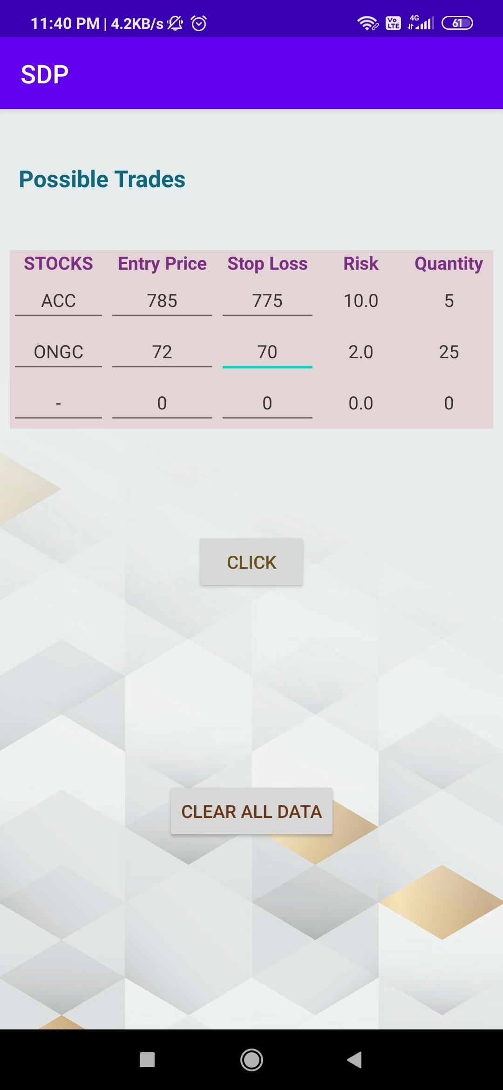

1. **Open Trades**

‘Open trades’ page deals with the ongoing trades. The user has to enter the details of the trades, which are currently in action. The application will calculate the profit and loss in each of the trades, which are then added and displayed on the home page. Users can see all the open trades in the list. The user can change the details like current market price or stop loss any time depending on the situation in the trade. After the completion of a particular trade, the page has an option to close the trades.

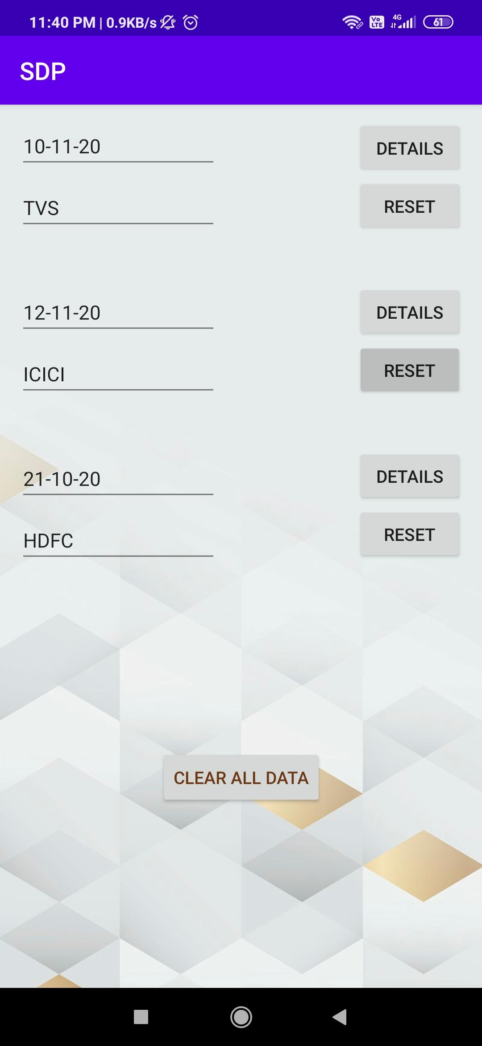

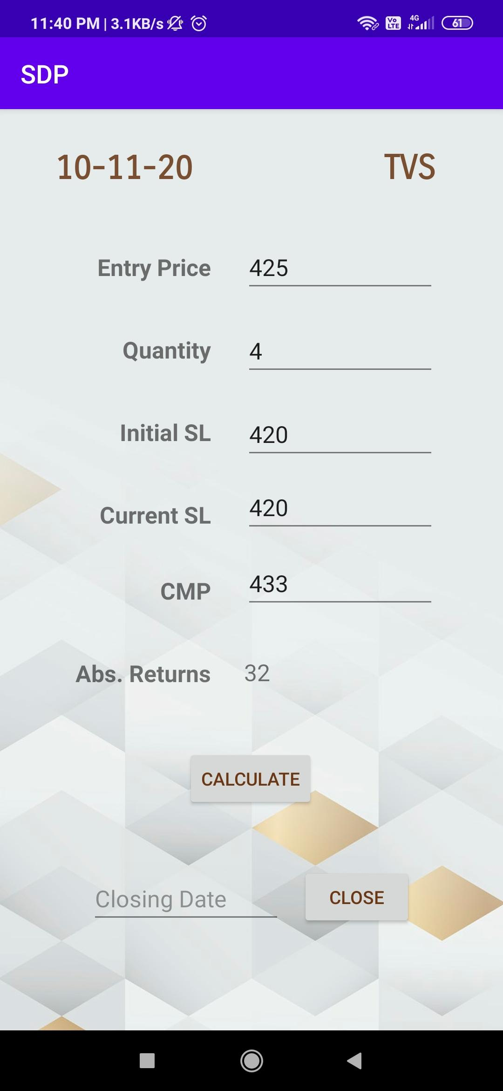

1. **Closed Trades**

After closing the trade in the open trades activity the data related to that stock gets added to closed trade activity. The data gets deleted from the open trades after closing the trade. In this page the user can see all the completed trades with their dates of entry and exit with returns from the trade. The app adds the returns of all closed trades and on the home page it is shown in the current capital section after adding with starting capital.

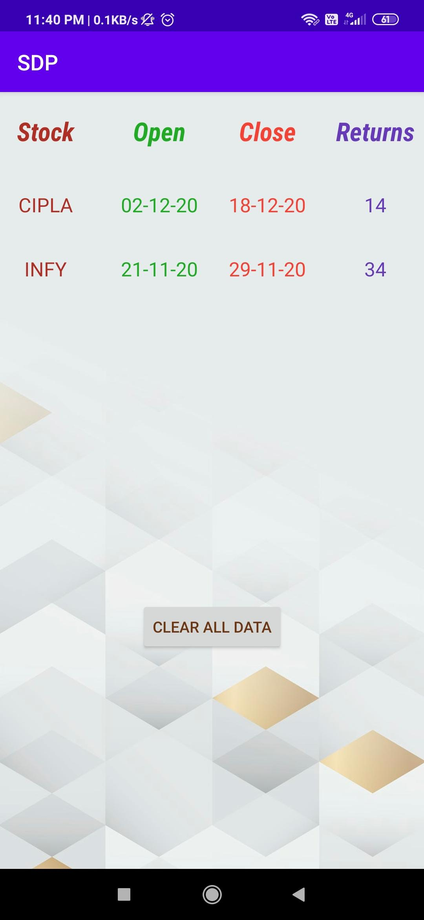

##### **Results and Discussion**

In this paper, an android application, which helps in money management for ease in trading, is proposed. The app provides a good interface of the money invested. Using this application, every step the user takes will be defined since there is a logic behind each step. The app works according to risk and suggests quantities to avoid hitting the worst-case scenario. The important feature of the app is, it works offline. The app does not require internet connection for storing or accessing data. A systematic money management platform is provided in this paper.

**References**

[1]<https://developer.android.com/training>

[2] Michał Wójtowicz, “Money management methods in trading and investing”, SGB-Bank S.A. Szarych Szeregów 23a 60-462 Poznań, Poland

[3] Shlok Datye, ”Money Management Principles for Mechanical Traders”, Master of Science Thesis Stockholm, Sweden 2012